**[What skill do I have to master to make my life great?](https://www.quora.com/What-skill-do-I-have-to-master-to-make-my-life-great" \t "_blank)**

1. Dress well.
2. Speak clear and confident.
3. Life purpose.
4. Respect.
5. Well manner.
6. Smile.
7. Speak truth.
8. Accepting situation.
9. Optimistic thinking.
10. Self belief's.
11. Education.
12. Good knowledge of any particular field.
13. Observation.
14. Self love.
15. Gratitude.
16. Broad mindset.
17. Take care Health.
18. Managing wealth.
19. Making true friends.
20. Handling failure and heartbreak.

**ARM Processor-Test1-Key Answers**

1. **Justify the following**
2. ARM is suitable for Embedded System applications
3. Code density will be improved using Thumb Instructions

Ans: (i) The following features that make ARM ideal for embedded applications

* Small processor for lower power consumption
* High code density for limited memory and physical size restrictions
* Can interface with slow and low-cost memory systems
* 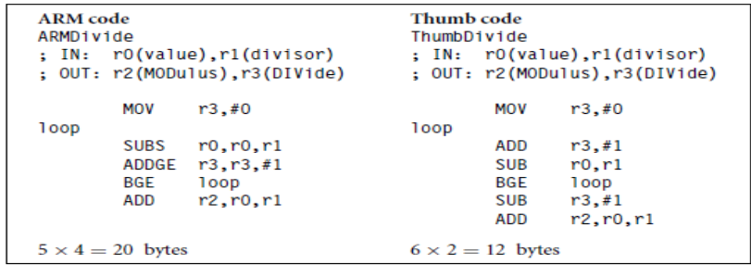Reduced die size for processor to accommodate more peripherals

The above table indicates that

* A thumb implementation of the same code takes up around 30% less memory than the equivalent ARM implementation
* Uses 70% of the space of the ARM code and uses 40% more instructions than the ARM

1. **Use the suitable single ARM instruction to perform the followingoperations**
2. R0 = ~ R1
3. R3 = R2 + R2 X 8
4. R6 = R5 – R4 / 16
5. R10 = R9 X R8 + R7
6. R12 = R11 + 12 if Z =1

Ans: (i) MVN R0,R1

(ii) ADD R3,R2,R2,LSL#3

1. SUB R6,R5,R4,LSR#4
2. MLA R10,R9,R8,R7
3. ADDEQ R12,R11,#12
4. **Compute the following**
5. Effective address of the instruction

STR R0, [R1], # -12 if register R1=0x200

1. The value of SP after executing the instruction

STMFD SP!, {R0, R1} if SP is 0x10001000 initially

1. The value in register R8 after execution of the instruction

RSB R8,R4,R5 If R4 = 15 and R5 = 20

1. The value in register R2 after execution of the instruction

MOVT R2,#0x1234

1. The value in register R2 after executing the instruction

EOR R2, #0xf<<0 If R2 = 0x1234 initially

Ans: (i) R1 – 12 = 0x200 – 12 = 0x1F4

1. 2 registers \* 4 bytes each = 8 bytes (0x08)

SP=0x10001000 – 0x08 = 0x10000FF8

1. R8 = R5 – R4 🡪R8 = 20 – 15 = 05
2. R2 = 0x12340000
3. R2 =0x123B

**Develop an ARM ALP to**

1. Transfer the five 32-bit numbers defined in the code memory to descending stack memory
2. Generate Table 5 in read-write memory

Ans: (i)

area reset,data,readonly

export \_\_Vectors

\_\_Vectors

dcd 0x10001000; initilization of stack memory

dcd Reset\_Handler

area mycode,code,readonly

entry

export Reset\_Handler

Reset\_Handler

ldr r0,=src

ldmia r0,{r1-r5}

stmfd sp!, {r1-r5}

stop b stop

src dcd 0x12345678, 0xabcdef01, 0x87654321, 0x1379ace1,0x98765432

end

area reset,data,readonly

export \_\_Vectors

\_\_Vectors

dcd 0

dcd Reset\_Handler

area mycode,code,readonly

entry

export Reset\_Handler

Reset\_Handler

mov r0,#10

ldr r1,=data1

mov r2,#5

cont strb r2,[r1],#1

add r2,r2,#5

subs r0,r0,#1

cmp r0,#0

bne cont

stop b stop

area mydata,data,readwrite

data1 space 0

end